Spring Boot Application:

Step-1

**Create Spring Boot Application**

Create Spring Boot Application and import the same in eclipse, STS or any other IDE

Step-2

**Maven clean**

Right click project->Runs As ->Maven clean

Step-3

**Maven Install**

Right click project->Runs As ->Maven install

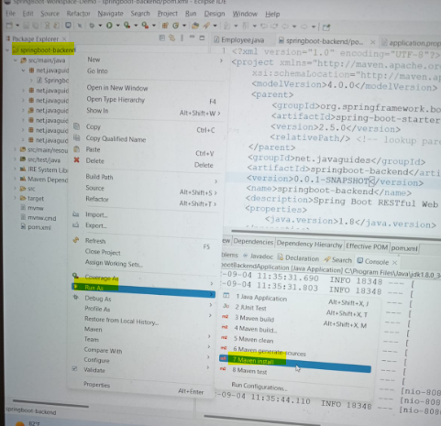

Step-4

**Run Spring Boot Application**

Right click Main Java File->Runs As ->Java Application(in STS “Run Maven Application”)

